**Kamov Ka-50 Black Shark**

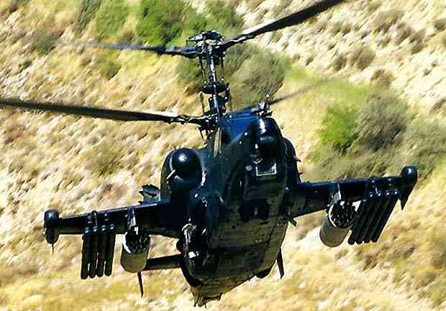

**Ka-50 Black Shark**

Any information about this helicopter was strictly secret in 70's and 80's. American intelligence services had problems to get any information about its development. The situation has rapidly changed a few years ago. Everybody could see the brand new Kamov helicopter on Paris Airshow 92' for the first time.

Helicopters from the Kamov Company have traditionally been given NATO codenames beginning with the letter "H", and the Ka-50 Black Shark helicopter carries the NATO codename Hokum A, Hokum B being the two-seat version, Ka-52. Ka-50 is also known as Werewolf. The Ka-50 Black Shark entered service in the Russian Army during 1995 and is in full production at the Sazykin Aviation Company Progress based in Arseniev maritime Territory, Russia. It is a high performance combat helicopter with day and night capability, high survivability and fire power to defeat air targets and heavily armored tanks armed with air defense weapons.

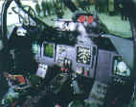

[**Ka-50-2 Erdogan**](http://www.military.cz/russia/air/helicopters/ka-50-2/ka-50-2.htm)

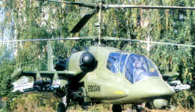

This type developed with cooperation between Russia and Israel is know as Ka-50-2 Erdogan. It was designed to meet conditions announced by Turkey Air Force. Erdogan is third the most modern two-seat tandem modification of Kamov Ka-50 with Israel avionics. Some weapons are of Israel origin as well.

**Ka-52 Alligator**

The success of any combat operation to support ground forces on the battlefield depends to a large extent on the joint combat actions of group combat helicopters. A group commander flying in a combat formation is responsible for control over subordinate helicopters. His helicopter should be fitted with more sophisticated equipment compared to the rest of the group to make him see better targets on the battlefield and be able to ensure target designation and distribution, provide for constant control over group combat helicopters and maintain communications with a ground command post. The scope of tasks assigned to the commander frees him from helicopter piloting. Consequently, he should fly in a two-seat flying combat vehicle.

The Ka-52, designated Alligator, multi-role all-weather combat helicopter, is intended for this purpose as a two-seat modification of the Ka-50 combat helicopter. Pilots accommodated side-by-side in one cockpit can fly this helicopter and handle all on-board systems. The Alligator retained all combat capabilities of its predecessor, including the whole array of weaponry. It is outfitted with a multifunctional on-board integrated electronic flight, navigation and weapon control system. Its passive/active observation/search and sighting systems ensure target search and their attack day/night in any weather conditions. The Sextant Avionic of France and Thomson company take part in creation of this helicopter. The Ka-52 Alligator is 85 percent identical to the Ka-50 base helicopter in terms of its airframe and main systems. Pilots escape via an ejection system. The Ka-52 Alligator can also be used as a trainer. Pilot accommodation and the availability of new multifunctional equipment system led to an increase in the weight of the empty helicopter and a certain deterioration in flight performance, compared to the Ka-50. However, it did not affect the integrated quality of this flying machine as a whole.

Externally, the Ka-52 combat helicopter differs from its predecessor in the front part of the fuselage, shape of the cockpit and arrangement of round-the-clock observation/search and sighting systems. Pilots are rigged with pressurized helmets fitted with built-in displays to provide for required flight and sighting data. The Ka-50 and Ka-52 helicopters feature interchangeability, thereby reducing costs for series production and joint operation in combat units.

Naturally, Alligator is more expensive than Black Shark. However, this is attributable to payments for the capability to perform combat missions on higher and more efficient levels. The advent of Ka-52 does not mean its automatic substitution by the Ka-50. They can be used more effectively in the interests of the ground forces, owing to their optimal joint employment in groupings. A similar approach is also adopted by the U.S. army aviation. The more costly and sophisticated AH-64D and AH-64D LongBow helicopter versions do not replace, but instead reinforce the [AH-64A Apache](http://www.military.cz/usa/air/in_service/helicopters/ah64/ah64_en.htm) helicopter groupings, thereby increasing their efficiency.

In the near future the Ka-52 will be subjected to tests. The Kamov company and its foreign partners are convinced of the successful results of the tests that will enable the Ka-52 helicopter to occupy a leading position in its class. It is up to foreign buyers to decide whether to choose the Ka-50 or the Ka-52 or a hybrid to meet their requirements.

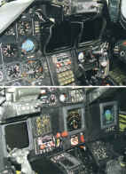

**Development**

The development of this helicopter had started in year 1978 according to specifications announced by Soviet Ministry of Defense in 1977. Codename V-80 was used till 1992, when the name Ka-50 was given to new Kamov helicopter. Kamov Ka-50 was designed for usage over the land, not for naval operations as almost all Kamov helicopters before (e.g. Ka-25 or Ka-27). The first model 1:1 was showed to Soviet Military Chiefs in May 1980. In two years on 17 June 1982 the first flight was accomplished. Kamov Ka-50 had serious competitor. Mil worked at the same time on brand new [Mil Mi-28](http://www.military.cz/russia/air/helicopters/Mi-28/Mi-28_en.htm) (known as Havoc now). Both aimed to win the tender for new helicopter. When testing Ka-50 and Mi-28 helicopters, Ka-50 seemed to be better. Mil wished tests of helicopters repeated. Three times both types were tested, but Ka-50 was better in every test. Soviet Ministry of Defense decided to continue development of both competitors.

The development of the Ka-50 Black Shark and AH-64A Apache combat helicopters aimed to redress this disparity and make the helicopters able to defeat tanks armed with air defense weapons. The Ka-50 combat helicopter can be used to defeat targets on the battlefield within wide ranges of launching high-precision supersonic antitank missile systems, including launches from more than a 6-km range within a stand-off zone of air defense artillery and air defense missile systems. The Ka-50 combat helicopter is intended to defeat modern armored and mechanized materiel, air targets and hostile manpower. This co-axial helicopter features a high flight performance and ease of piloting via automated flight devices. It can successfully execute combat missions day/night owing to high survivability under hostile fire, powerful armament and comfortable pilot's cockpit. The helicopter was tested in simulated combat conditions. . The Ka-50 helicopter is unrivalled in the world in terms of the 'cost-efficiency' criteria. In 1995 the Ka-50 combat helicopter entered service and is now series produced at Progress Arsenyevsk-based aviation complex.

**Avionics**

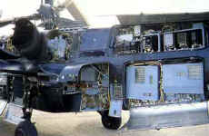

Flight systems include inertial navigation system (INS), autopilot and head-up display (HUD). HUD of Ka-50 is the same as in Mig-29. Sensors include FLIR (forward-looking infrared) and terrain-following radar.

**Engines**

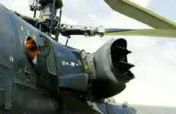

The Ka-50 is powered by two TV3-117VMA turboshafts engines each providing 2,200 horsepower. The power plant is fitted with deflectors and separators to prevent dust ingestion in the air intakes which protects the engines from wear when taking off from unprepared sites. The engines are placed on either side of the fuselage to enhance the combat survivability. The helicopter also has an auxiliary power unit (APU) for self-contained operation.

**Weapon systems**

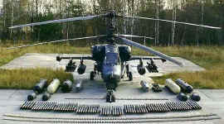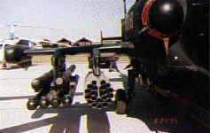

The Ka-50 helicopter is fitted with observation and sighting systems together with navigation, communication and other systems to enable one crew-member to pilot and engage hostile forces in combat. A combination of various armaments to a maximum combat weapon load of 2 tons are selected according to the combat mission, including anti-tank missiles, unguided aerial rockets of different calibers, air-to-air missiles, guns, bombs and other weapons.

The helicopter has small mid-mounted wings fitted with four underwing suspension units and wingtip countermeasures pods. Up to 12 Vichr supersonic antitank missiles with unified warheads against ground armored and air targets can be mounted on the helicopter's two underwing external stores. There can be also attached stores with 23-mm guns or additional fuel tanks.

The missiles are automatically guided to the selected air or ground target using laser beam riding and feature a high degree of jam resistance. The Vichr missile has a target hit probability close to one, against a tank at a range of up to 8 km. The kill probability is also rated very highly with the capability of penetrating all types of Armour including active Armour up to 900 mm thick.

The Ka-50 is armed with a 2A42 quick-firing 30-mm gun which has an unrestricted azimuth and elevation range mounting for use against airborne or ground targets. The gun is mounted near the centre of gravity of the helicopter for consistent accuracy. The gun is equipped with 460 rounds of ammunition, two types being carried, high-fragmentation and explosive incendiary rounds and Armour-piercing rounds. The pilot selects the type of ammunition in flight. The weight of the ammunition is 0.39 kg each round, the muzzle velocity is 980 m/s and the range is up to 4 km. The gun provides an angular firing accuracy of 2 to 4 Mrad.

**Co-axial rotors**

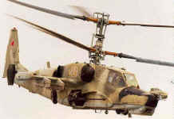

The coaxial rotor design provides a hovering ceiling of 4,000 meters and vertical rate of climb of 10 meters per second at an altitude of 2,500 meters. The rotor blades are made from polymer materials. The hingeless main rotor head requires no lubrication.

The coaxial-rotor configuration results in moments of inertia values relative to vertical and lateral axes being between 1.5 to 2 times less than the values found in conventionally designed combat single rotor helicopters with tail rotors. Absence of the tail rotor enables the helicopter to perform flat turns within the entire flight speed range. A maximum vertical g-load of 3.5 combined with low moments of inertia give the Ka-50 a high level of agility and maneuverability.

**Survivability**

Two separately mounted engines at a maximum distance reduce the probability of their simultaneous damage. The powerplant has an operational life of 30 minutes without oil, giving the pilot the opportunity to land in a safe location in the event that the oil system is damaged in combat. The helicopter also has duplicated and stand-by hydraulic and power systems and main control circuits.

Extensive all-round Armour installed in the cockpit protects the pilot against 12.7 mm Armour piercing bullets and 23 mm projectile fragments. The rotor blades are rated to withstand several hits of ground-based automatic weapons providing the capability of safe flight completion after sustaining impact.

Protection of fuel tanks against explosion hazards and fuel leakage is provided by porous fuel tank fillers and fuel tank self-sealing covers, and a comprehensive fire extinguishing system is installed. Engine exhaust heat screens reduce the thermal signature of the helicopter and flare dispensers protect the helicopter against heatseeking missiles.

The Ka-50 is the world's first operational helicopter with a rescue ejection system, which allows pilot to escape at all altitudes and speeds. The K-37-800 Rocket Assisted Ejection System is manufactured by the Zvezda Research and Production Enterprise Joint Stock Company in the Moscow Region. The seat operates by pulling the pilot from the helicopter cabin using a solid-propellant rocket motor. The system comprises the seat, a control unit and a pullout rocket motor. The seat is fitted with a survival pack containing an NAZ-7M survival kit, a life raft and a PS-37A parachute system. The seat provides safe forced emergency escape from helicopters in the speed range 0 to 350 km/hour and at altitude 0 to 6,000 meters. The seat also provides safe ejection during inverted flight (at speeds 0 to 330 km/h with zero vertical velocity) at a minimum altitude of 90 meters. Pilot is ejected in max. six second.

Ka-50 is fitted with radar warning receiver, electronic warfare system and chaff and flare dispenser UV-26.

**Maintenance**

Built in test and diagnostics equipment ensures fast maintenance turnaround time. Under operational conditions the helicopter has a 12-day combat availability with minimum maintenance during off-base deployment.

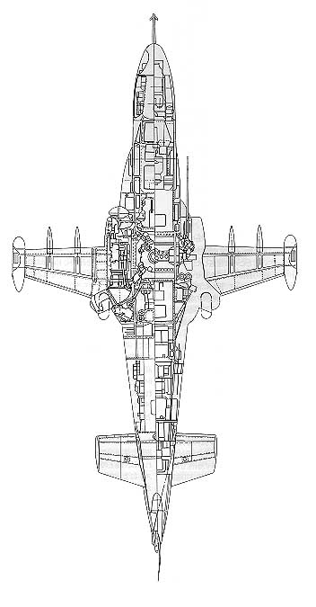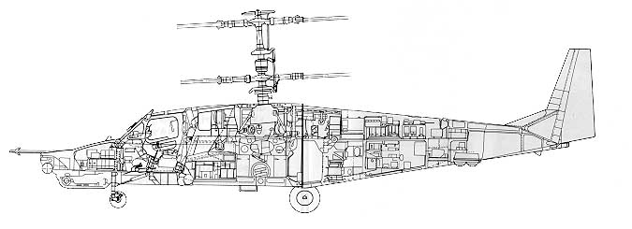

**SPECIFICATION**

|  |  |
| --- | --- |
| **Dimensions** |  |
|  |  |
| Main rotor diameter | 14.5 meters |
| Length with rotating rotors | 15.9 meters |
| Overall height | 4.9 meters |
| Wing span | 7.3 meters |
|  |  |
| **Weights** |  |
|  |  |
| Empty weight | 7,692 kg |
| Normal take off weight | 9,800 kg |
| Maximum take off weight | 10,800 kg |
| Weight of consumable combat load | 610 kg |
| Weight of maximum combat load | 1,811 kg |
|  |  |
| **Engines** |  |
|  |  |
| **Power plant** |  |
| two TV3-117VMA engines | 2 x 2,200 h.p. |
|  |  |
| **Landing gear** |  |
| Retractable tricycle nosewheel type landing gear |  |
|  |  |
| **Performance** |  |
| Maximum level flight speed | 310 km/h: |
| Diving speed | 390 km/h |
| Cruise speed | 270 km/h |
| Hovering ceiling | 4,000 meters |
| Service ceiling | 5,500 meters |
| Vertical rate of climb at 2,500 m | 10 m/s; |
| Range of flight with normal take-off weight | 460 km |
| Ferry range | 1,160 km |

**Ka-50 and its competitors**

|  |  |  |  |
| --- | --- | --- | --- |
|  | **Kamov Ka-50** | [**Mil Mi-28**](http://www.military.cz/russia/air/helicopters/Mi-28/Mi-28_en.htm) | [**AH-64 Apache**](http://www.military.cz/usa/air/in_service/helicopters/ah64/ah64_en.htm) |
| **Main rotor diameter** | 14,50 m | 17,00 m | 14,63 m |
| **Length with rotating rotors** | 16,00 m |  | 17,76 m |
| **Maximum take off weight** | 10 800 Kg | 11 400 Kg | 9580 Kg |
| **Maximum speed** | 350 Km/h |  |  |
| **Maximum level flight speed** | 310 Km/h | 305 Km/h | 295 Km/h |
| **Hovering ceiling** | 4000 m | 5800 m | 6100 m |
| **Vertical rate of climb at 2,500 m** | 10,00 m/s |  |  |

**Video**

[Kamov Ka-50 cannon attack (215kB)](http://military.boskowan.net/Video/web/ka-50_cannon.mpeg)

[Kamov Ka-50 rocket attack (312kB)](http://military.boskowan.net/Video/web/ka-50_missiles.mpeg)